Title of Paper Using Small Caps in Times New Roman 16
Name Surname, Place here the author information using style "Authors" but put the name in bold font as illustrated here. The email address should always be one tab in on a new line
first.author@university.ac.uk
Name Surname, Information Systems Evaluation and Integration Network Group (ISEing) School of Information Systems, Computing & Mathematics, Brunel University, UK second.author@university.ac.uk
Name Surname, Information Systems Evaluation and Integration Network Group (ISEing) School of Information Systems, Computing & Mathematics, Brunel University, UK third.authors@university.edu

Abstract – Style "Subtitle"
The abstract of the paper is written like normal text, Times New Roman Italic. The abstract should be informative and concise and maximum of 300 characters in length. Use here the style "Abstract".
Keywords: One, Two, Three, Four.

Heading 1 Times New Roman 12 Bold in Small Caps Style “Heading 1”
Normal text in times new roman 11. Use singe space. Use style “normal text”. Don’t add blank lines between paragraphs – let the styles do the work.

Heading 2 in bold times new roman 11 use style “heading 1”
Don’t use excessive numbers of headings two is often enough and three should be an exception. Try to keep headings concise and avoid them running onto multiple lines. Use title case on level 1 headings but only capitalise the first word at level 2 and 3.

Heading 3 in times new roman 10 “style heading 3”
Normal text again here.
Large quotations should use this italic style “Quote” (Doe, 2001)
Normal text again here.
EMBED Word.Picture.8 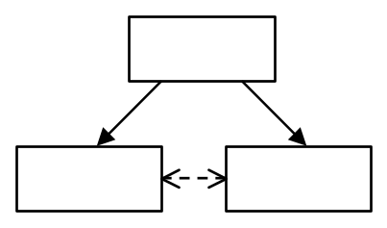
Figure 1. This is how you label figures and tables. Use the style "Figure" to place the object centred above this line and for this title use “Figure title” style.
You don’t need to add extra a space before or after a figure let the styles do the work again.
However, insert one blank paragraph before a table.

PG Students 25-30 | Height meters | Av. Weight kgs
Male | 0 | 0
Female | 0 | 0
Table 2. This is how you label tables. Centre tables without making columns wider than necessary.. The styles for the text in table cells are called "Table" and “Table header”. Some cells may need special alignment. The style for this line is again “Figure title”.
See below for bullet points "Bullet":
- The style "Bullet" should be used here. This is a complementary text
  - The style "Bullet 2" should be used here. This is a complementary text.
Place any acknowledgements before the reference list using Subtitle style for the heading. The citations and the reference list should be in Harvard form and look like the examples show below. The word style is called "Reference list".

Conclusions
Describe in short not more than 300 characters the most important results of the work (contributions).

References (style "Subtitle" here)
Love P.E.D and Irani Z. 2003. 'A project management quality cost information system for the construction industry'. Information and Management, 40(7): 649-661.
Irani Z and Love P.E.D. 2002. ‘Developing a Frame of Reference for Ex-ante IT/IS Investment Evaluation’. European Journal of Information Systems, 11(1): 74-82.

